Software Design Process

Process Policy

- Design methodologies shall be adopted in software design based on the application domain.
- Design tools (tools aiding design and/or documentation) shall be used, wherever applicable
- Design alternatives will be considered for satisfying the Quality requirements of the Client

All Rights Reserved

This document is a property of Trianz. No part of this document may be copied or reproduced in any form or by any means, electronic, mechanical or otherwise without the prior written permission of Trianz.

Owner: Anil D K | RID: QMS/5101/0208
Email: qmg@trianz.com | Version: 10.00
Date: 04-May-06 | Total Pages: 10
Distribution List: All employees of Trianz
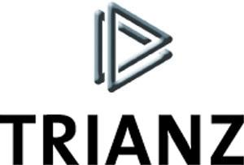
3rd Floor, Hulkul Brigade Centre
# 82, Lavelle Road
Bangalore – 560 001

Phone: +91-80-22127870
E-mail: contactus@trianz.com

Table of Contents
1 Introduction 3
1.1 Definitions/Acronyms/Abbreviations 3
1.2 Objective(s) 3
1.3 Scope 3
1.4 Roles and Responsibilities 3
1.5 Prerequisites 3
1.6 References 4
2 Process Flow 5
3 Entry Criteria 6
4 Inputs 6
5 Process Description 6
5.1 Design Strategy 6
5.2 Selection of a Design Team 6
5.3 Design Quality Objective 6
5.4 Development of Design 7
5.5 Design Review 8
6 Outputs 8
6.1 Deliverables 8
6.2 Quality Records 8
7 Exit Criteria 9
8 Process Assets 9
9 Measurement 9
10 Tailoring Guidelines 9
11 Standards Addressed 10
Revision History 10

Introduction
This process describes the procedure/steps involved in design aspects of the application/product to be delivered and covers all the requirements documented in SRS. The design is developed using the Design Template and a Design Guidelines as suggested in the template. The design may be split into High Level and Low Level design.

Definitions/Acronyms/Abbreviations
Word/Abbreviations/ Acronyms | Definition/Description
SRS | System Requirements Specification
HLD | High Level Design
LLD | Low Level Design
PM | Project Manager

Objective(s)
- To define the structure of the product/modules so that the requirements are met
- To evaluate the design prior to construction

Scope
This document does not discuss how to design, but just indicates as to what should be covered in the design document.

Roles and Responsibilities
Role | Responsibility | Internal/External
Project Manager | - Ensure that the design methodologies and tools to be followed for the applicable software design practices are available  - Ensure that the design alternatives are reviewed and selected based on the selection criteria (The alternative selection would normally depend on how well the alternative meets the functional and non-functional requirements of the client.)  - Get the selected design reviewed by a review team and by the Client if required.  - Approve the design before construction of the software commences | Internal
Designer | - Develop multiple design alternatives of the modules  - Prepare the design document | Internal
Review Team Members | - Review the design from implementation point of view | Internal/External
Client | - Review and approve the design (if stated in the contract) | External

Prerequisites

Resource
- Design Engineers
- Engineering Tools for Design

Training
- Design methodologies and Tools
- Project Domain

References
Document Number | Document Name
QMS/5101//0207 | System Requirements Specification Process
QMS/5101/0206 | Project Management Planning Process
QMS/5101/0211 | Review Process
QMS/5101/0216 | Project Tracking Process

Process Flow
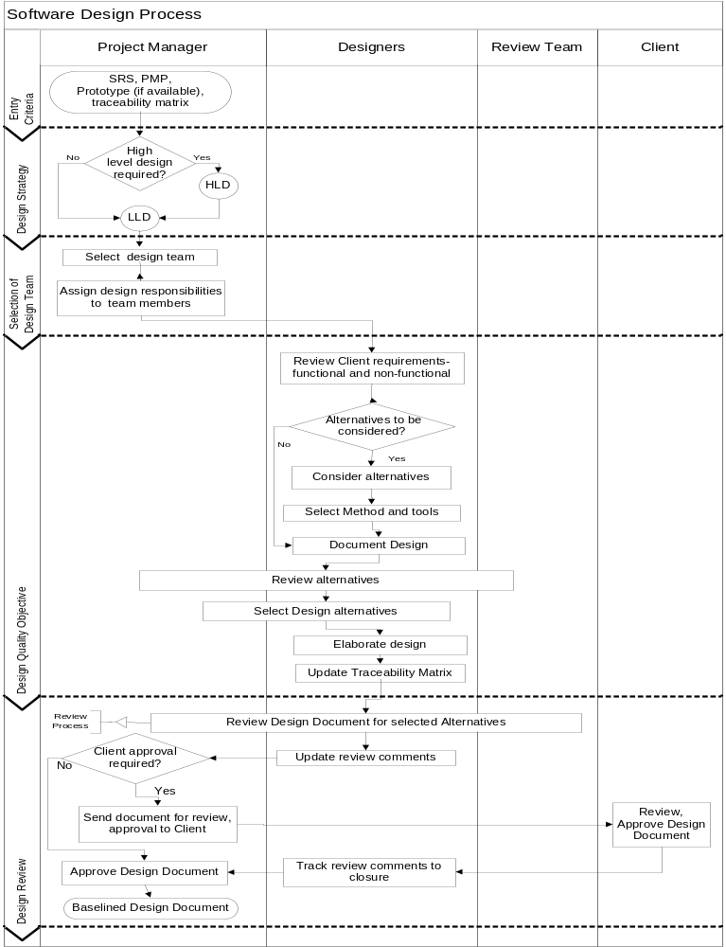

Entry Criteria
- Requirement study has been completed

Inputs
- SRS
- Traceability Matrix
- Baselined Project Management Plan
- Prototype (if available)

Process Description

Design Strategy
- The PM decides on the Design strategy for the project based on the type, size and complexity of the project.
- Some of the factors that influence the design strategy are:
- Technology maturity of the Client
- Contractual obligations
- Depth and clarity of requirements
- Tools and technology to be used in the project, and the like
- Based on the above the PM decides upon
- The Design team composition
- Split of Design as High Level and Detailed Design
  - This in turn could be decided between development of a single Design document or multiple design documents;
- Review strategy - one review or review of high level design followed by review of detailed design
- Reuse/ Build/ Purchase certain components
- Design Alternatives to be considered and the level at which it is to be considered
- Based on the use/ application of design by the Client, the contract may mandate or the PM may decide to develop technical documentation for use by the Client. In most cases the design document itself suffices as deliverable to the Client. Refer to Design Document template and Project Management Plan Process for details of deliverables to Client and planning for the same

Selection of a Design Team
- The PM chooses design team from within the project team for development of System Architecture, High Level and Detailed Design of the system to be developed
- The PM assigns various elements of the design to be developed by different team members

Design Quality Objective
- The Design Team reviews the functional and non-functional requirements of the Client
- The design team comes up with the Design Quality objectives based on the non-functional requirements of the Client. These Design Quality Objectives form the basis of the Design alternatives to be developed

Development of Design

Design Alternatives
- Based on the design strategy, the design team may consider alternatives both at high level and detailed level of design or selectively for certain components at detailed level
- PM may choose to develop multiple design alternatives at high level design based on:
- Client quality objectives
- Project development using different technologies
- Provide alternatives to make decision to use reusable components; build or buy components
- In the case of a large and complex project the PM gets the high level design reviewed by the identified reviewers, specifically the recommended alternative, and then proceeds to complete the detailed design
- PM may also decide to develop high level design with only adequate details for all the alternatives and then detail the design of the selected alternative only. Refer to Design Guidelines.
- If the design strategy is to consider alternatives at detailed design level, the design team selects specific modules/components that impact the design quality objectives to be met and develop design alternatives for those modules/components
- The design alternatives may form the basis for making decision to reuse/build/buy components
- The design team documents the following associated with each of the Design alternatives proposed, both at high level and detailed level:
- Advantages
- Limitations
- Constraints
- Assumptions and
- Risks
- After checking the completeness of the various design alternatives the design team submits the same to the PM along with the recommendation for preferred design alternative and reason for the preference, for initial review. The team also provides all supporting documents required for review
- The review team as per the review strategy reviews the design alternatives to check the ability of the design alternatives to meet the quality objectives of the project. Refer to Review process for details of conducting reviews
- The review team considers the recommendation of the design team and may accept it with or without modification or suggest another alternative
- The criteria for selecting a specific alternative and the working sheets are documented and stored in the project repository, clearly stating the assumptions, constraints and risks involved in implementing the selected alternative. Refer to Project Tracking process for details on tracking risks associated with a select alternative

Selection of Design Methodology and Tool
- The design team selects a suitable methodology depending on the type of the project and/or domain to which the application/product belongs and any other requirements to cover all the implementation aspects of the system to be developed
- The design team selects a tool for design development. This might be as specified by the Client or selected from tools available in the organization. Different tools and methodology can be selected for different design alternatives

Design Development
The design team documents the design based on the design strategy for the project. Refer to Design Document Template

      - High Level Design
  - The design team develops the high level design
  - Design may be developed using one or more of the following:
- System Architecture
- Business Process Diagram
- Process Modeling Diagram (Data Flow Diagram)
- Functional Hierarchy Diagram
- Class Interface Diagram
- Class description document
- Modules
- Screen Designs
- File Structures
- Interface Modules, etc
.
      - Detailed Design
- The design team develops one or more of the detailed design elements as applicable
- Conceptual Data Model (Entity Relationship Diagram)
- Data Dictionary
- Physical Data Modeling (Tables, Indexes,)
- Pseudo code / Program specifications
- Screen specifications
- Detailed description of the data objects / data structures
- Control flow etc.
- The designer updates the details in the corresponding section of the design document for each of the alternatives
- The depth/detail level at which the design should be developed is discussed and decided between the PM and the design team based on the size and complexity of the project.
- The Author designate from the design team completes the design document, elaborating the selected design alternative with the help of the design team
- The design team updates the traceability matrix
- The Author sends the Design along with the traceability matrix and other reference documents for review to the Review team

Design Review
- The author subjects the design document for a technical review as per Review Process. The reviewers review the design document using the design review checklist. Refer to Design Review Checklist
- On completion of review, the design team incorporates the review comments and tracks them to closure
- The PM verifies the design document and traceability matrix for completion, approves and baselines for use
- If specifically agreed in the contract, PM sends the baselined design to the Client for review and approval
- PM gets the review comments from the Client. Resolves and tracks the same to closure and baselines for use.

Outputs

Deliverables
- Approved design documents
- Updated Traceability Matrix

Quality Records
Quality Record | Responsibility
Review defect log for the design document | PM
Design approval | PM

Exit Criteria
- Design document is approved for implementation.

Process Assets
Document Number | Document Name
QMS/5101/0107 | Design Document template
QMS/5101/0293 | Design Guidelines
QMS/5101/0058 | Design Review Checklist

Measurement
- Planned vs. Actual effort spent for design
- Ratio of defects relating to design vs. Total number of defects identified for the entire product/application

Tailoring Guidelines
Process Step | Tailoring provided | Recommendation
Creation/updation of design document for migration/porting projects, where the architecture of the application changes | Creation/updation of relevant design documents  - Is mandatory, where standard guidelines are not available  - Is optional where standard guidelines are available | To be documented in PMP
Updates to existing Design document  [In the event of projects where Trianz is involved in component development and client/other vendor is involved in system integration] | Inputs to update the existing product design document is sufficient in client specified format | To be documented in PMP, as derived from the proposal
Creation/updation of design document for migration/porting projects, where the architecture of the existing application remains same | - Porting Guide/Investigation report is sufficient to proceed further  - May create/update the design document depending on the customer requirements | - To be documented in PMP  - Delivery manager to take this call
Creation/updation of design document for maintenance projects, where the architecture of the existing application remains same | - Design documents at component/module level is sufficient  - May create/update the design document depending on the customer requirements | - Refer to the existing Engineering documents of the application  - Delivery manager to take this call
Creation of design document for a short project | Capturing the essence of requirements & design in the existing design template is sufficient | - To be documented in PMP

Standards Addressed
ISO 9001:2000
Clause |  |  | Description
7.3.1 |  |  | Design and development planning
CMMI
Process Area | Practice | Description
Technical Solution | SP 1.1 | Develop Detailed Alternative Solutions and Selection Criteria
 | SP 1.2 | Evolve the operational concept, scenarios (Addressed in Design Template)
 | SP 1.3 | Select Product-Component Solutions
 | SP 2.1 | Design the Product or Product Component
 | SP 2.2 | Establish and maintain a complete technical data package (Addressed in Release process. Creation of manuals like installation/User based on requirements)
 | SP 2.3 | Design product-component interfaces (Only in case of product development, by default the interface with external components are taken care of as part of input itself)
 | SP 2.4 | Perform Make, Buy or Reuse Analysis

Revision History
Rev. No. | Author | Date | Reason for Change | Change Description
1.00 | Vandana M | 20th Sep 1997 | None | None
7.01 | Vivek | 17-Dec-04 | Merger with Trianz | - Changed EximSoft name to Trianz
8.00 | Anandi | 22-Dec-04 | Review for baseline | - Approval for baseline
9.00 | Vandana | 10-Nov-05 2005 | CMMI Compliance | - Made changes in the process to address Design Quality Objectives and considering Design alternatives before selecting a design  - Appendix A removed
9.01 | Anandi | 25-Jan-06 | Review | - Reorganized the process steps
10.00 | Balu Nair | 04-May-06 | Approved by Anilkumar DK | - Baselined

